MANUAL TESTING ASSIGNMENT
IDBI Bank – “Help Us Contact You” Form
Test Scenarios · Test Cases · Defect Reports

Submitted By | Naveen Pandey
Application Under Test | IDBI Bank Website – “Help Us Contact You” Enquiry Form
Testing Type | Manual Functional Testing
Deliverables | 20 Test Scenarios, 5 Test Cases, 3 Defect Reports

Contents
- 1. Testing Approach (Steps 1–5)
- 2. Deliverable 1 – Test Scenarios (TS001–TS020)
- 3. Deliverable 2 – Test Cases (TC001–TC005)
- 4. Deliverable 3 – Defect Reports (BUG001–BUG003)
- 5. Conclusion

1. Testing Approach

Step 1: Requirement Analysis
- Read the requirement of the “Help Us Contact You” form carefully.
- Identify all input fields and their validations (Name, Age, Location, Contact Number, Email, Pincode, Services Required, CAPTCHA, Authorization checkbox).
- Understand which fields are mandatory and which are optional.
- Understand the expected system behaviour on successful and unsuccessful submission.

Step 2: Identify Test Scenarios
- Prepare scenarios for page load and form display.
- Prepare scenarios for Name, Age, Location, Contact Number, Email and Pincode fields.
- Prepare scenarios for Services Required, CAPTCHA, Authorization checkbox and Submit button.

Step 3: Prepare Test Cases
- Write positive and negative test cases for the key form fields.
- Use Boundary Value Analysis and Equivalence Partitioning where applicable (e.g. Age, Contact Number, Pincode).
- Define the Expected Result for every test case.

Step 4: Execute Testing & Log Defects
- Execute all test cases against the live form.
- Capture a screenshot of every failed test.
- Record Expected Result vs Actual Result.
- Assign Severity and Priority to each defect.

Application Under Test – Reference Screenshots
The screenshots below show the actual IDBI Bank website and the 'Help Us Contact You' (Apply Now) enquiry form used for this testing assignment.
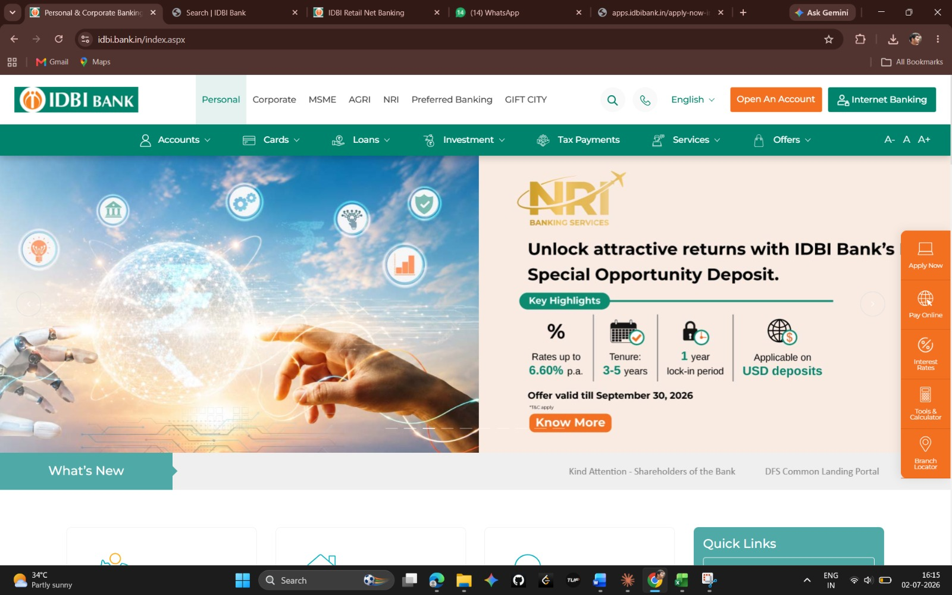
IDBI Bank Home Page – idbi.bank.in
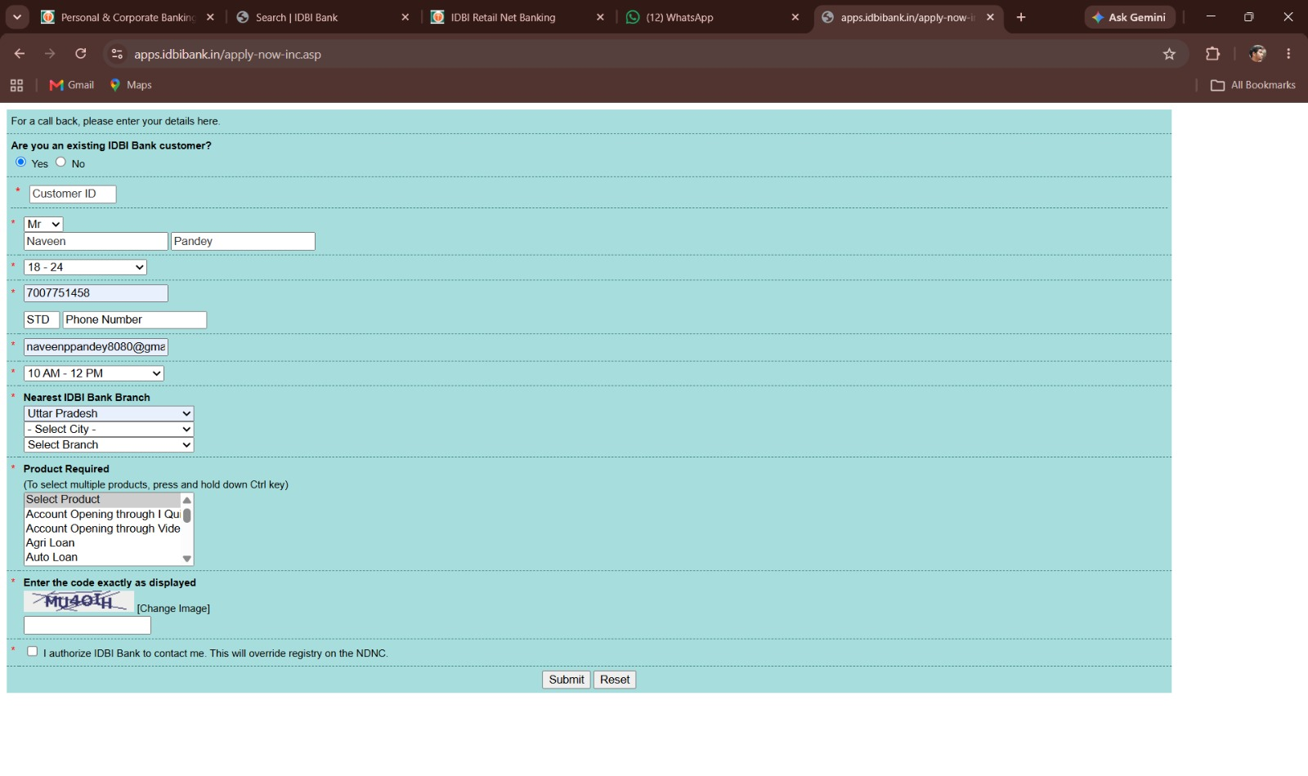
'Help Us Contact You' enquiry form – initial blank view
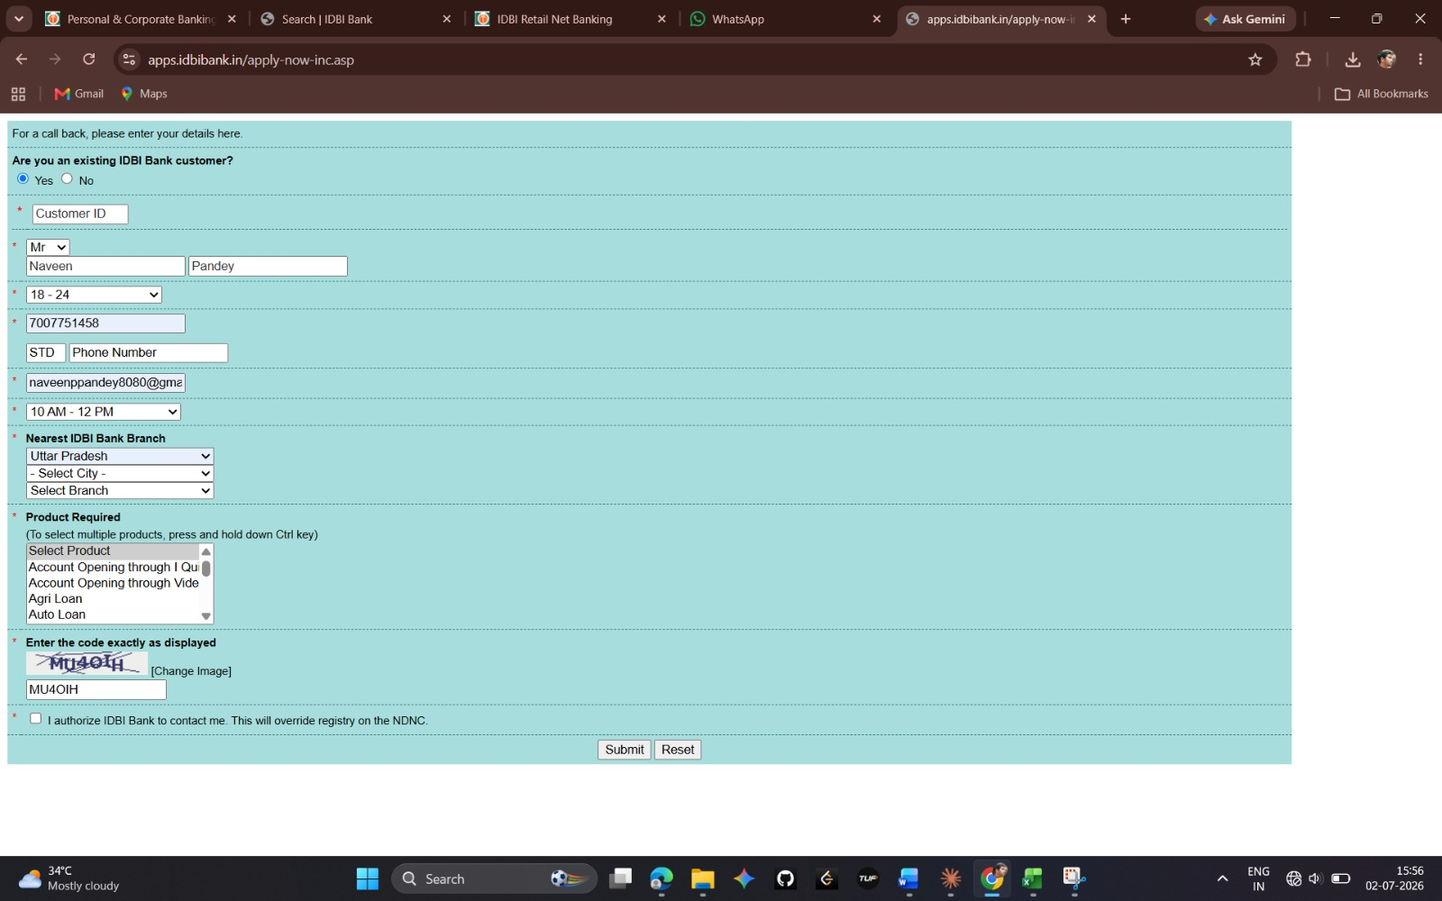
Form with contact details and CAPTCHA correctly entered

2. Deliverable 1 – Test Scenarios
The table below lists 20 test scenarios (TS001–TS020) covering page load, Name, Age, Location, Contact Number, Email, Pincode, Services Required, CAPTCHA, the Authorization checkbox, and Submit validations.
TS ID | Test Scenario | Field / Module
TS001 | Verify the IDBI Bank Home Page loads successfully within acceptable time. | Page Load
TS002 | Verify the 'Help Us Contact You' form is displayed with all required fields. | Page Load
TS003 | Verify the Name field is mandatory and shows an error when left blank. | Name
TS004 | Verify the Name field accepts valid alphabetic input (with spaces). | Name
TS005 | Verify the Name field rejects numeric and special-character input. | Name
TS006 | Verify the Age field is mandatory and shows an error when left blank. | Age
TS007 | Verify the Age field accepts valid numeric values within an acceptable range. | Age
TS008 | Verify the Age field rejects negative numbers, zero, and non-numeric input. | Age
TS009 | Verify the Location/State field is mandatory and shows an error when left blank. | Location
TS010 | Verify the Location dropdown lists all valid states/cities. | Location
TS011 | Verify the Contact Number field is mandatory and shows an error when left blank. | Contact Number
TS012 | Verify the Contact Number field accepts a valid 10-digit mobile number. | Contact Number
TS013 | Verify the Contact Number field rejects entries that are less/more than 10 digits or contain letters/special characters. | Contact Number
TS014 | Verify the Email field is mandatory and shows an error when left blank. | Email
TS015 | Verify the Email field accepts a properly formatted email address. | Email
TS016 | Verify the Email field rejects an improperly formatted email address (e.g., missing '@' or domain). | Email
TS017 | Verify the Pincode field accepts a valid 6-digit numeric pincode and rejects invalid/incomplete entries. | Pincode
TS018 | Verify the Services Required field is mandatory and allows selection of one or more services. | Services
TS019 | Verify the CAPTCHA field validates correct input and rejects incorrect/blank CAPTCHA entries before submission. | CAPTCHA
TS020 | Verify the Authorization checkbox is mandatory and the Submit button only proceeds when all validations pass. | Authorization / Submit

3. Deliverable 2 – Test Cases
Five detailed test cases were derived from the scenarios above, covering both positive and negative flows.
TC001: Valid Submission
Precondition | User is on the ‘Help Us Contact You’ form.
Test Steps | 1. Enter a valid Name.2. Enter a valid Age.3. Select a valid Location.4. Enter a valid 10-digit Contact Number.5. Enter a valid Email address.6. Enter a valid 6-digit Pincode.7. Select at least one Service Required.8. Enter the correct CAPTCHA.9. Check the Authorization checkbox.10. Click Submit.
Test Data | Name: Rohit Sharma | Age: 29 | Contact: 9876543210 | Email: rohit.sharma@example.com | Pincode: 400001
Expected Result | Form is submitted successfully and a confirmation message is displayed.
Priority | High

TC002: Name Field Validation
Precondition | User is on the ‘Help Us Contact You’ form.
Test Steps | 1. Enter numbers/special characters in the Name field (e.g. 'Rohit123!').2. Fill remaining fields with valid data.3. Click Submit.
Test Data | Name: Rohit123!
Expected Result | System should display a validation error and prevent submission until a valid Name is entered.
Priority | Medium

TC003: Contact Number Validation
Precondition | User is on the ‘Help Us Contact You’ form.
Test Steps | 1. Enter an invalid Contact Number (less than 10 digits or containing letters).2. Fill remaining fields with valid data.3. Click Submit.
Test Data | Contact Number: 98765
Expected Result | System should display a validation error such as 'Enter a valid 10-digit mobile number' and prevent submission.
Priority | High

TC004: Invalid Email Validation
Precondition | User is on the ‘Help Us Contact You’ form.
Test Steps | 1. Enter an improperly formatted email address.2. Fill remaining fields with valid data.3. Click Submit.
Test Data | Email: rohit.sharma@com
Expected Result | System should display a validation error such as 'Enter a valid email address' and prevent submission.
Priority | Medium

TC005: Mandatory Services Required Validation
Precondition | User is on the ‘Help Us Contact You’ form.
Test Steps | 1. Leave the Services Required field unselected.2. Fill remaining fields with valid data.3. Click Submit.
Test Data | Services Required: (none selected)
Expected Result | System should display a validation error prompting the user to select at least one service, and should prevent submission.
Priority | High

4. Deliverable 3 – Defect Reports
Three defects were logged during execution of the test cases above, each with steps to reproduce and supporting screenshots.

BUG-001: Services Required Field Not Validated
TS_018 | Verify Services Required Field | To verify that the system validates the Services Required field and shows an error if left blank.
STEP 5 – DEFECT REPORTS (WITH SNAPSHOTS)
Bug ID BUG-001  Title Form submitted despite 'Services Required' being left unselected  Module Enquiry Form  Severity High  Priority High  Environment Windows 10, Chrome 124  Steps toReproduce 1. Fill all fields except Services Required.2. Leave Services Required unselected.3. Click Submit.4. Observe no error message displayed.  Actual Result System allows submission without selecting any service.  Expected Result A validation error should be shown, like 'Please select at least one service'.  Status Open | 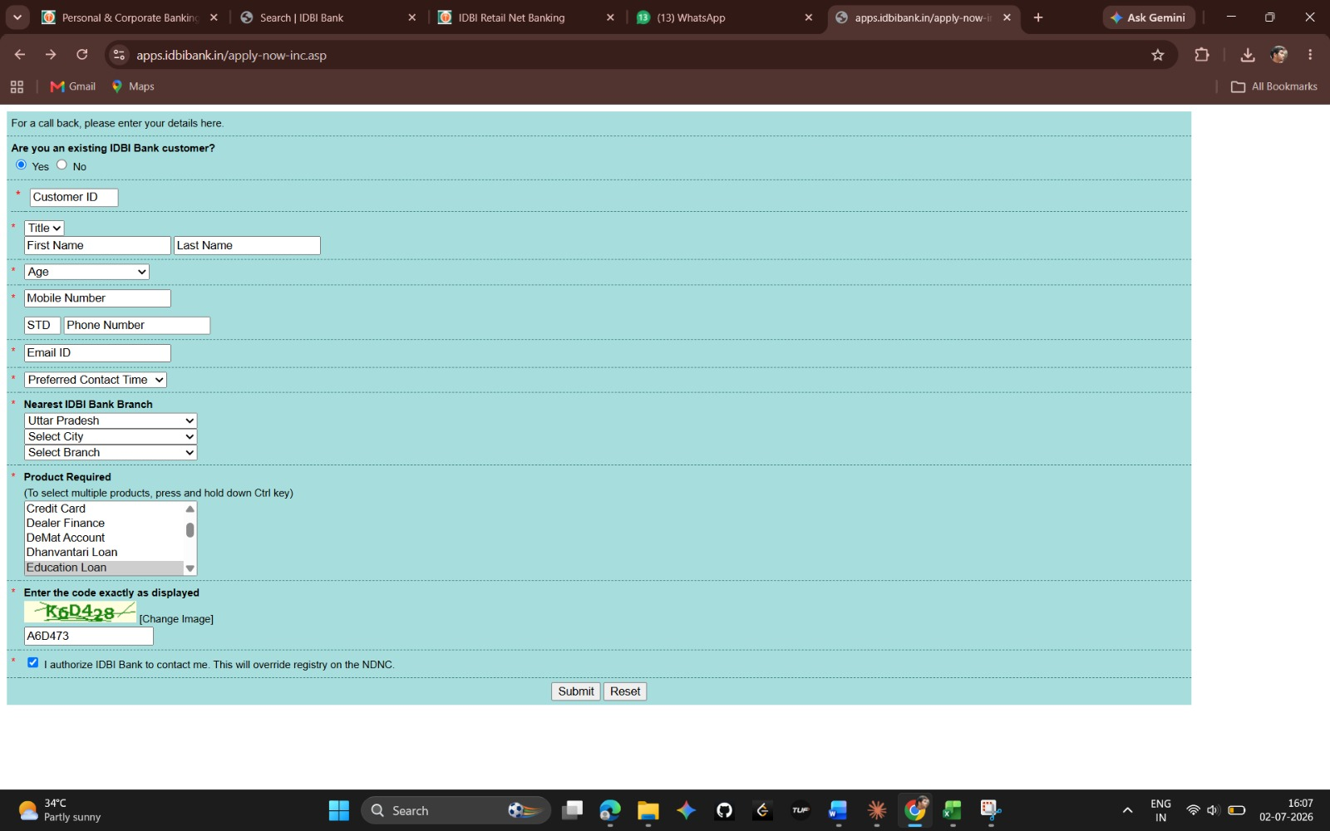  Step 1: Form filled, Services Required left blank  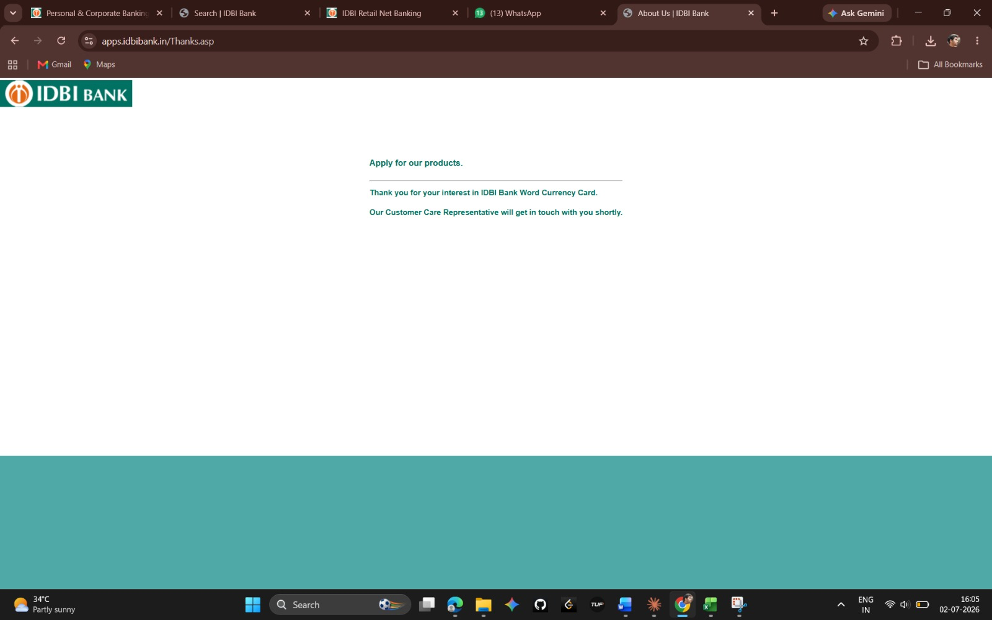  Step 2: Confirmation shown despite missing selection

- Fill all fields, leave Services Required unselected.
- Click Submit.
- Expected: Validation error.
- Actual: No validation shown.
- Severity: High

BUG-002: Incorrect CAPTCHA Accepted
TS_019 | Verify CAPTCHA Validation | To verify that the system validates the CAPTCHA and rejects incorrect entries before submission.
STEP 5 – DEFECT REPORTS (WITH SNAPSHOTS)
Bug ID BUG-002  Title Form accepts submission even when CAPTCHA entered is incorrect  Module Enquiry Form  Severity Critical  Priority Critical  Environment Windows 10, Chrome 124  Steps toReproduce 1. Fill all mandatory fields with valid data.2. Enter an incorrect CAPTCHA value.3. Click Submit.4. Observe no CAPTCHA error is shown.  Actual Result Form is submitted successfully despite the wrong CAPTCHA.  Expected Result System should reject the submission and show a 'CAPTCHA does not match' error.  Status Open | 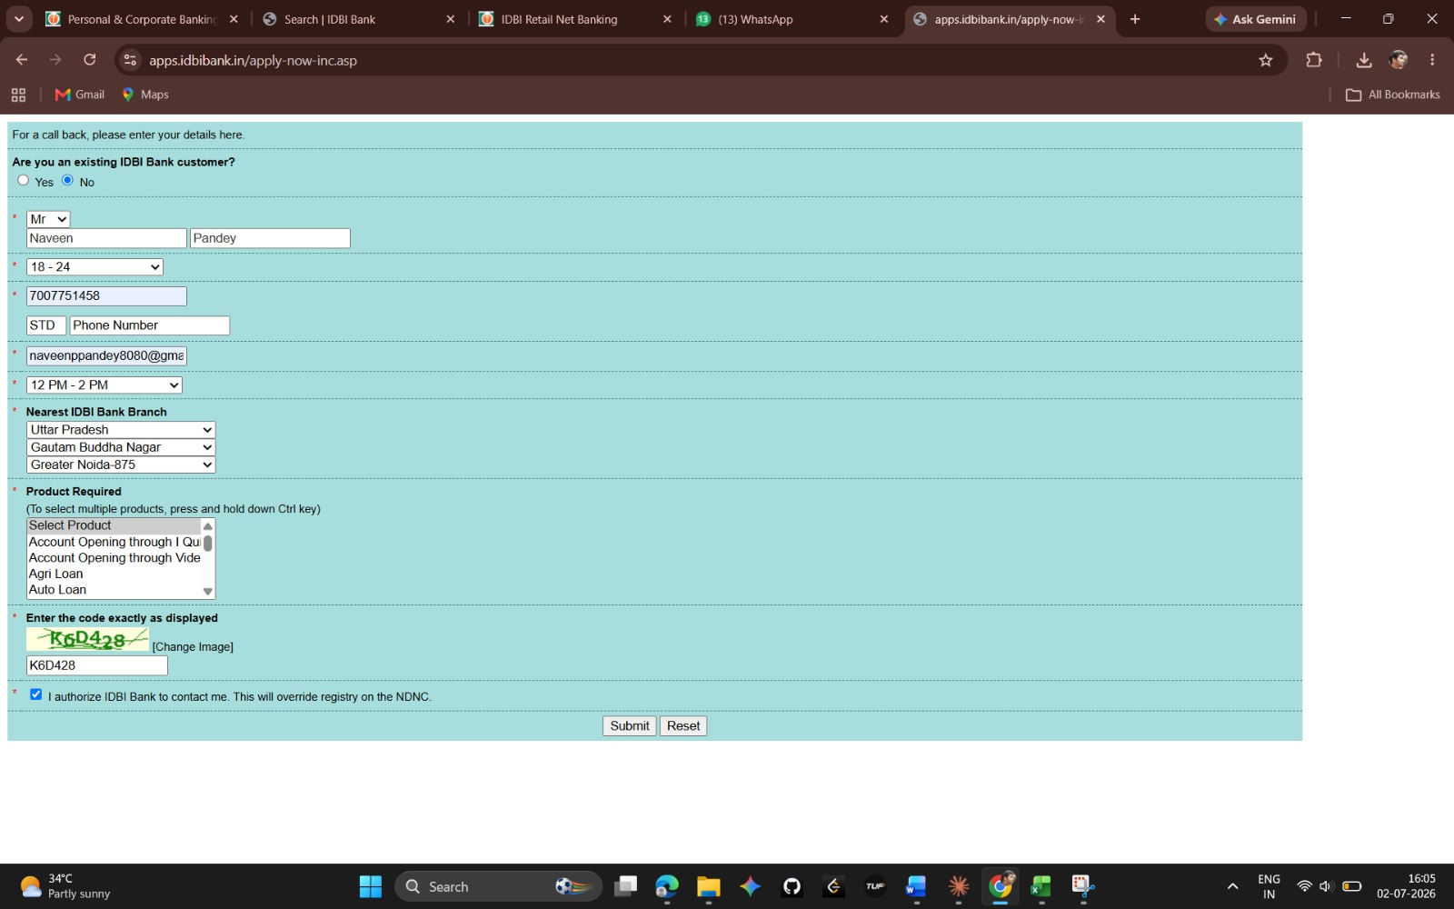  Step 1: Incorrect CAPTCHA entered (K6D428 → A6D473)    Step 2: Confirmation shown despite wrong CAPTCHA

- Fill all fields with valid data.
- Enter an incorrect CAPTCHA value and click Submit.
- Expected: CAPTCHA error message.
- Actual: Form submitted successfully.
- Severity: Critical

BUG-003: Submit Button Unresponsive
TS_020 | Verify Submit Button Functionality | To verify that the system submits the form and returns a confirmation when fully valid data is entered.
STEP 5 – DEFECT REPORTS (WITH SNAPSHOTS)
Bug ID BUG-003  Title Submit button does not respond after entering fully valid data  Module Enquiry Form  Severity Critical  Priority Critical  Environment Windows 10, Chrome 124  Steps toReproduce 1. Fill all fields with valid data, including Product Required and CAPTCHA.2. Check the Authorization checkbox.3. Click Submit.4. Observe the page does not respond.  Actual Result No confirmation message or redirection occurs after clicking Submit.  Expected Result System should submit the form and display a confirmation message.  Status Open | 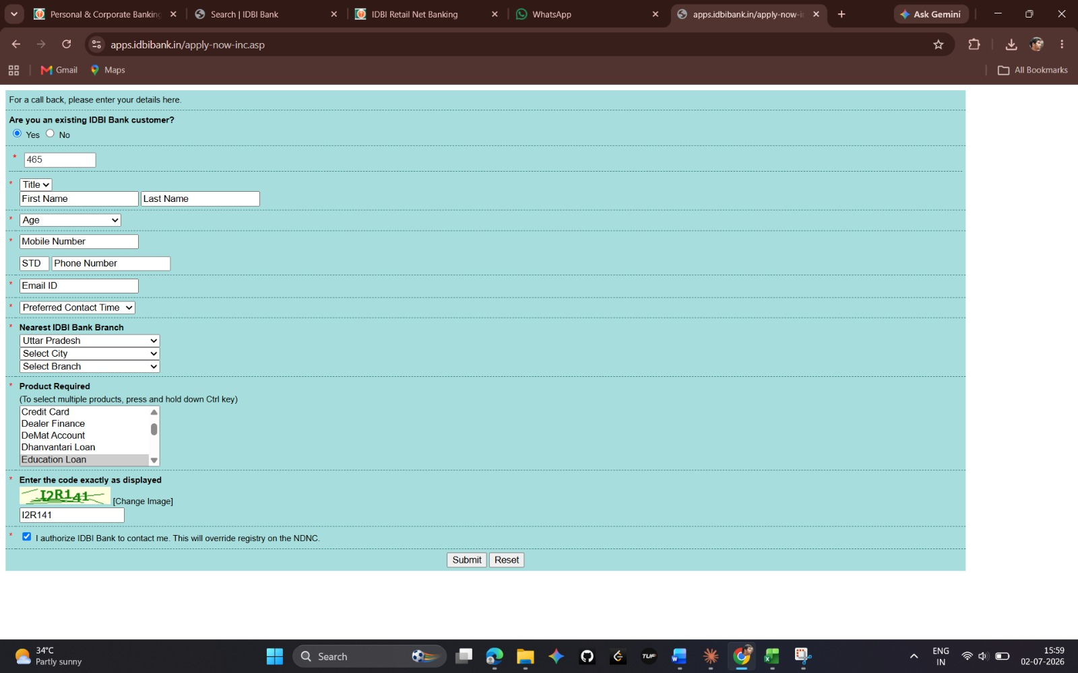  Step 1: Valid data entered, ready to submit    Step 2: Same page shown after clicking Submit – no response

- Fill all fields with valid data, including CAPTCHA.
- Click Submit.
- Expected: Confirmation message received.
- Actual: No response from the system.
- Severity: Critical

5. Conclusion
Manual functional testing of the IDBI Bank ‘Help Us Contact You’ form was carried out using 20 test scenarios and 5 detailed test cases covering page load, field-level validations, mandatory checks, CAPTCHA verification, and form submission.
Three defects were identified during execution:
- BUG001 (High): The Services Required field can be left unselected without any validation error.
- BUG002 (Critical): The form accepts submission even when an incorrect CAPTCHA is entered.
- BUG003 (Critical): The Submit button does not respond when the form is filled with fully valid data.
These defects should be prioritized for a fix, as they directly affect data integrity (BUG001), form security (BUG002), and the core submission functionality (BUG003) of the enquiry form.

